JAVASCRIPT LAB
PRACTICAL No. 9
Name:
PRN:
File Path:
Aim
To implement localStorage and sessionStorage to save user preferences such as theme settings, and to build a webpage that demonstrates both.
Theory
Web Storage lets a webpage keep key/value pairs (strings) inside the browser, without a server or cookies. Data is never sent to the server and can hold about 5 MB per site.
Feature | localStorage | sessionStorage
Lifetime | Stays until cleared by the user or code | Removed when the tab is closed
Scope | Shared by all tabs of the same site | Only the tab that created it
Used here for | Theme, text size, name, visit count | Draft note, page-load count

Method | Purpose
setItem(key, value) | Stores a value under the given key
getItem(key) | Reads the value (returns null if missing)
removeItem(key) | Deletes one key
clear() | Deletes every key in that storage
Procedure
- Create index.html with a form: name, theme (3 options), text size and where to save.
- Style it in style.css using CSS variables; each theme only redefines the colours.
- In script.js, read saved preferences with getItem() and JSON.parse() when the page opens.
- On every change, update the data-theme attribute and write the object back with JSON.stringify().
- Store the typed note and page-load count in sessionStorage; store total visits in localStorage.
- Reload the page and close/reopen the tab to confirm what is kept and what is lost.
Key Code
// Save (objects must become strings)
localStorage.setItem("prefs", JSON.stringify(prefs));

// Load, then apply the theme to the page
const prefs = JSON.parse(localStorage.getItem("prefs")) || {};
document.documentElement.setAttribute("data-theme", prefs.theme);

// Session-only data (cleared when the tab closes)
sessionStorage.setItem("draft", textarea.value);

Output
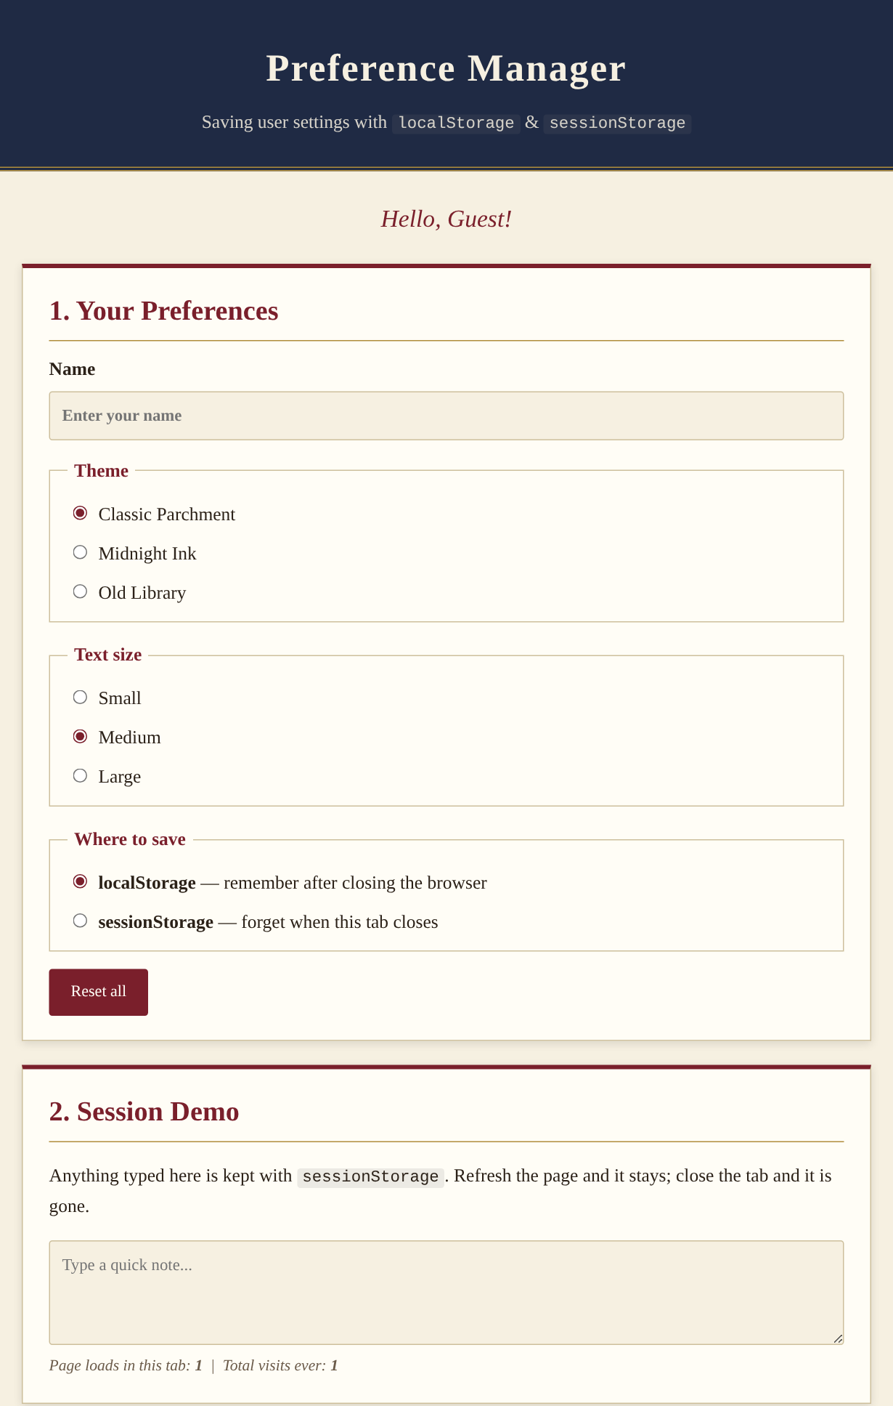  Fig. 1: First load (default Classic theme, Guest) | 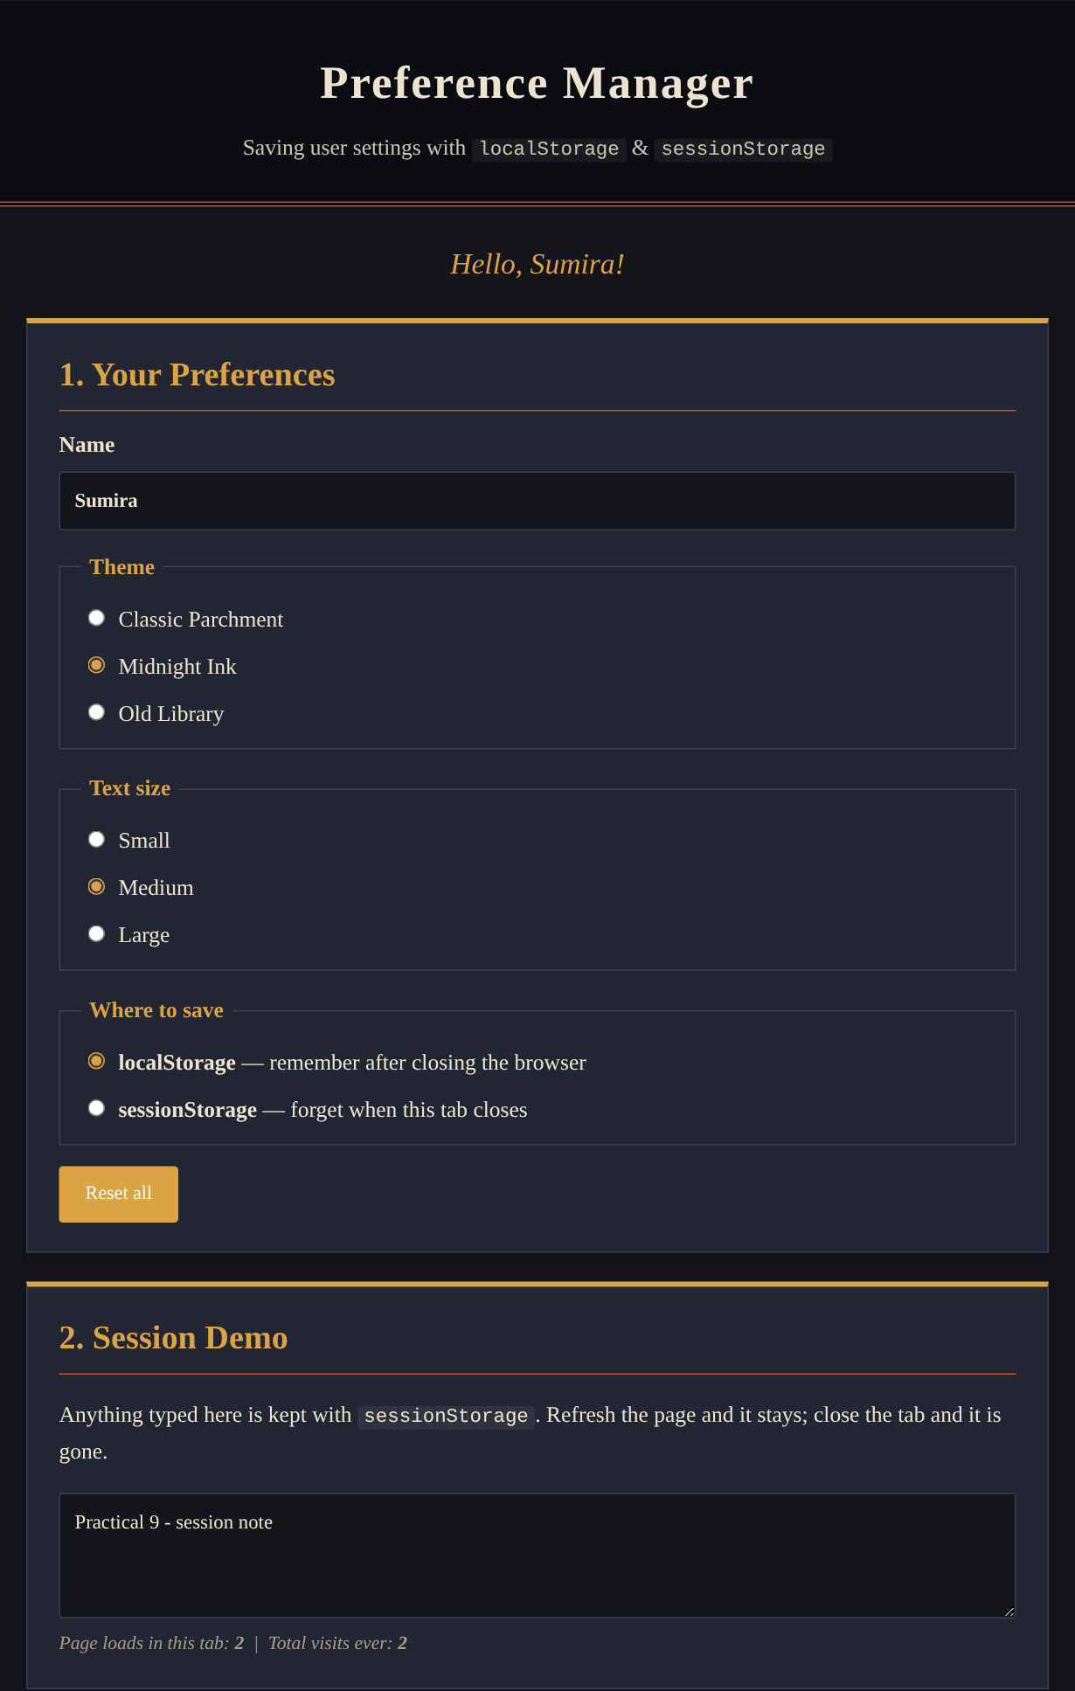  Fig. 2: Midnight Ink theme saved and restored after reload

Storage | Values saved after Fig. 2
localStorage | prefs = {"name":"Sumira","theme":"dark","size":"md"}
localStorage | visits = 2, mode = local
sessionStorage | draft = "Practical 9 - session note", loads = 2
Conclusion
The preferences chosen by the user (theme, text size, name) were saved in localStorage and were restored on reload, with no flash of the old theme because they are applied before the page is drawn. The draft note and load counter in sessionStorage survived a refresh but belong only to that tab and disappear when it is closed. Hence localStorage suits long-term preferences, while sessionStorage suits temporary, per-tab data.

